FINAL REPORT

Date | JULY 2026
Team ID
Project Name | Heritage Treasures: An In-Depth Analysis of UNESCO World Heritage Sites in Tableau
Maximum Marks | 4 Marks

INTRODUCTION

1.1 Project Overview
The project titled “Heritage Treasures: An In-Depth Analysis of UNESCO World Heritage Sites in Tableau” is a data-driven visualization initiative designed to explore, analyze, and present insightful patterns within the UNESCO World Heritage Sites dataset. This dataset encompasses a diverse range of cultural and natural sites recognized globally for their universal value, encompassing ancient monuments, architectural marvels, ecosystems, and more.
With globalization, tourism, and urban development intensifying, there is an increasing need to preserve and understand our shared heritage. This project addresses that need by transforming historical and categorical data into interactive, easy-to-understand visual stories. The use of Tableau, a leading business intelligence and data visualization tool, allows for dynamic representation of large datasets through various charts, maps, and dashboards.
The dataset used in this project includes key attributes such as the name of each site (Name_en), the country where the site is located (Country), the geographical region (Region), the year the site was inscribed (Date_inscribed), and whether the site is currently classified as "In Danger" (Danger). These attributes are used to build multiple dashboard components that together form a comprehensive, interactive platform for analysis.
"Heritage Treasures: An In-Depth Analysis of UNESCO World Heritage Sites (2019)" is a comprehensive project aimed at exploring the rich dataset of UNESCO World Heritage Sites using Tableau. This project focuses on visualizing the distribution, trends, and key attributes of these sites to provide valuable insights. By leveraging the power of data visualization, stakeholders can gain a
deeper understanding of the global heritage landscape, identify patterns, and make informed decisions to enhance the preservation and promotion of these sites.
Key features of the project include:
- A Tree Map showing the number of heritage sites per country.
- A Pie Chart highlighting the proportion of sites in danger.
- A Line Graph tracking site inscription trends across regions over time.
- Filters and tooltips to enhance user interactivity and exploration.
This project is not just a technical implementation but also a meaningful application of data analytics to support heritage conservation and education. It serves a dual purpose of showcasing technical skills in Tableau and contributing to the understanding of cultural heritage distribution worldwide.

1.2 Purpose
The purpose of this project is multidimensional, combining technical, educational, and social goals:

1. Data Visualization for Heritage Awareness
The project seeks to bring visibility to the UNESCO World Heritage Sites by presenting the data in an accessible and engaging visual format. Instead of traditional static reports or spreadsheets, the interactive dashboards allow users to explore the data themselves—drilling down into specific countries, comparing trends over decades, and identifying endangered sites.

2. Supporting Preservation Efforts
By identifying the number and condition of sites in each region and highlighting those classified as "In Danger," the project provides valuable insights for policymakers, conservationists, and NGOs. It helps prioritize regions and sites that require immediate intervention and can serve as a decision- support tool in planning conservation strategies.

3. Educational Insight
The project also has an academic and awareness-building dimension. Educators, students, and tourists can use the dashboards to learn more about world heritage in an interactive way. The insights into historical trends and regional distributions deepen the understanding of how and where heritage conservation is evolving.

4. Demonstrating Tableau Capabilities
On a technical front, the project aims to demonstrate how Tableau can be effectively used to turn raw datasets into visually compelling and informative dashboards. It showcases various visualization techniques such as filtering, tooltips, interactive maps, and storytelling dashboards.

5. Data-Driven Decision Making
Lastly, the project promotes data literacy and encourages a culture of data-driven thinking. By enabling users to interact with real-world data, it empowers stakeholders to base their insights and strategies on actual patterns rather than assumptions.

Ideation Phase Brainstorm & Idea Prioritization Template

Date | JULY 2026
Team ID
Project Name | Heritage Treasures: An In-Depth Analysis of UNESCO World Heritage Sites in Tableau
Maximum Marks | 4 Marks

Brainstorm & Idea Prioritization Template:
Brainstorming provides a free and open environment that encourages everyone within a team to participate in the creative thinking process that leads to problem solving. Prioritizing volume over value, out-of-the-box ideas are welcome and built upon, and all participants are encouraged to collaborate, helping each other develop a rich amount of creative solutions.
Use this template in your own brainstorming sessions so your team can unleash their imagination and start shaping concepts even if you're not sitting in the same room.
Reference: https://www.mural.co/templates/brainstorm-and-idea-prioritization

Step-1: Team Gathering, Collaboration and Select the Problem Statement

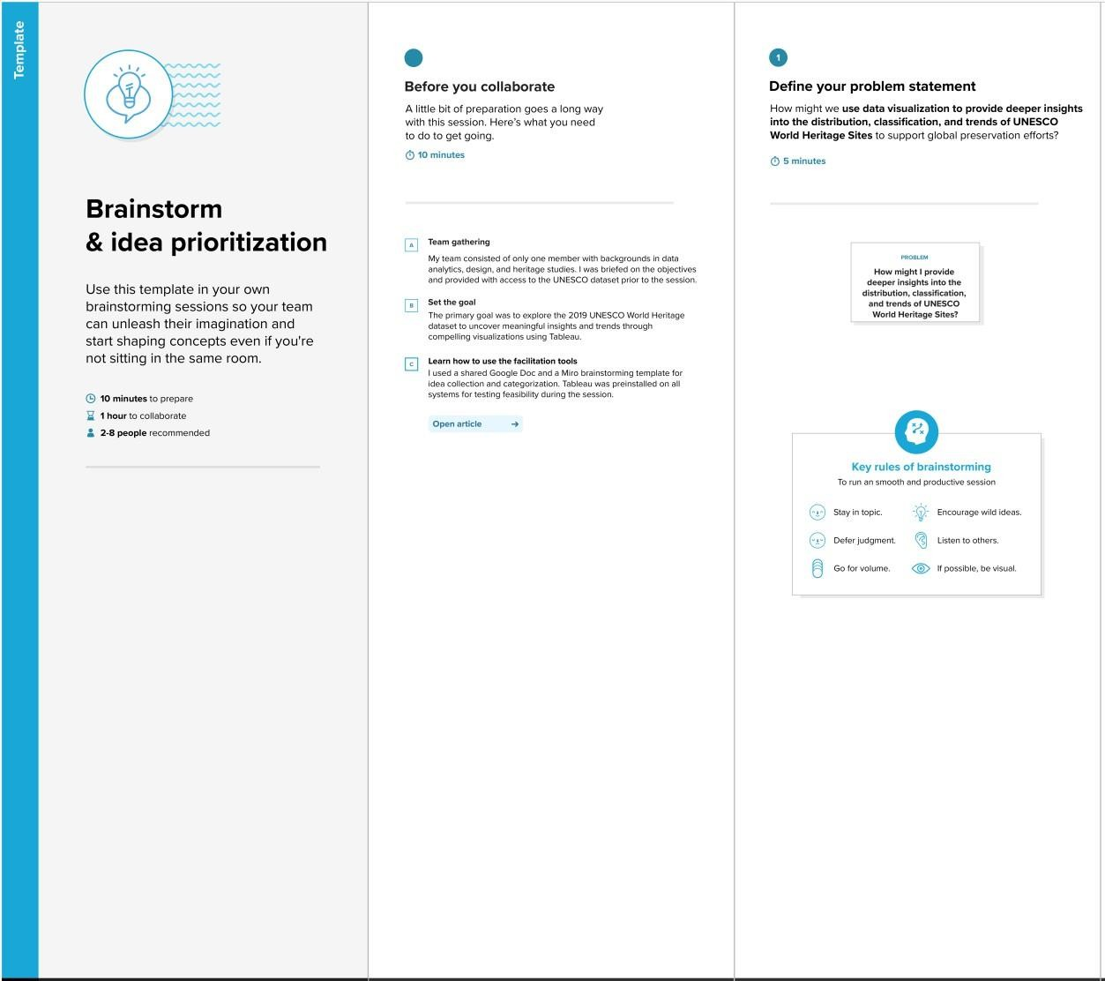

Step-2: Brainstorm, Idea Listing and Grouping

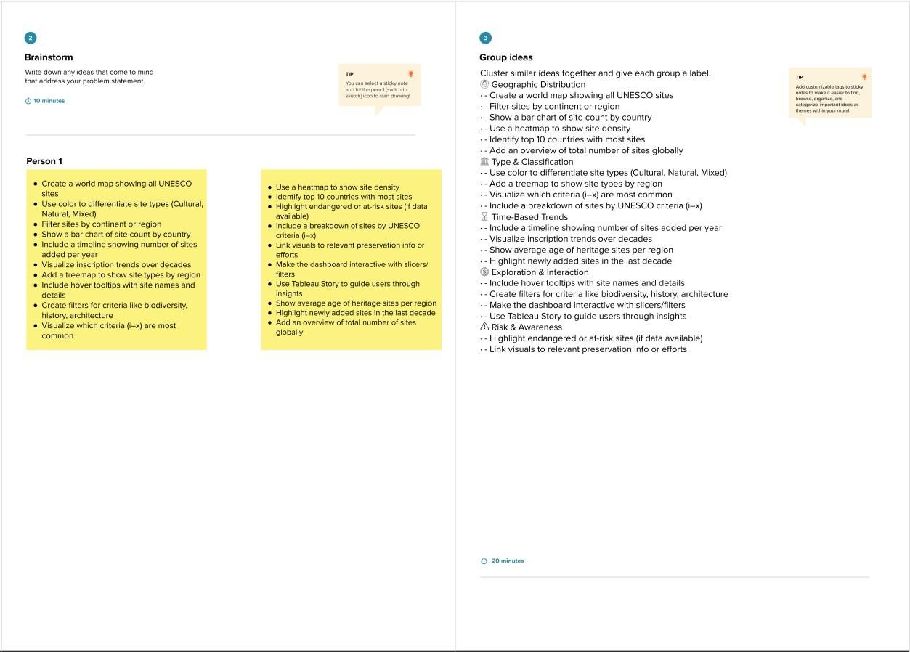

Step-3: Idea Prioritization
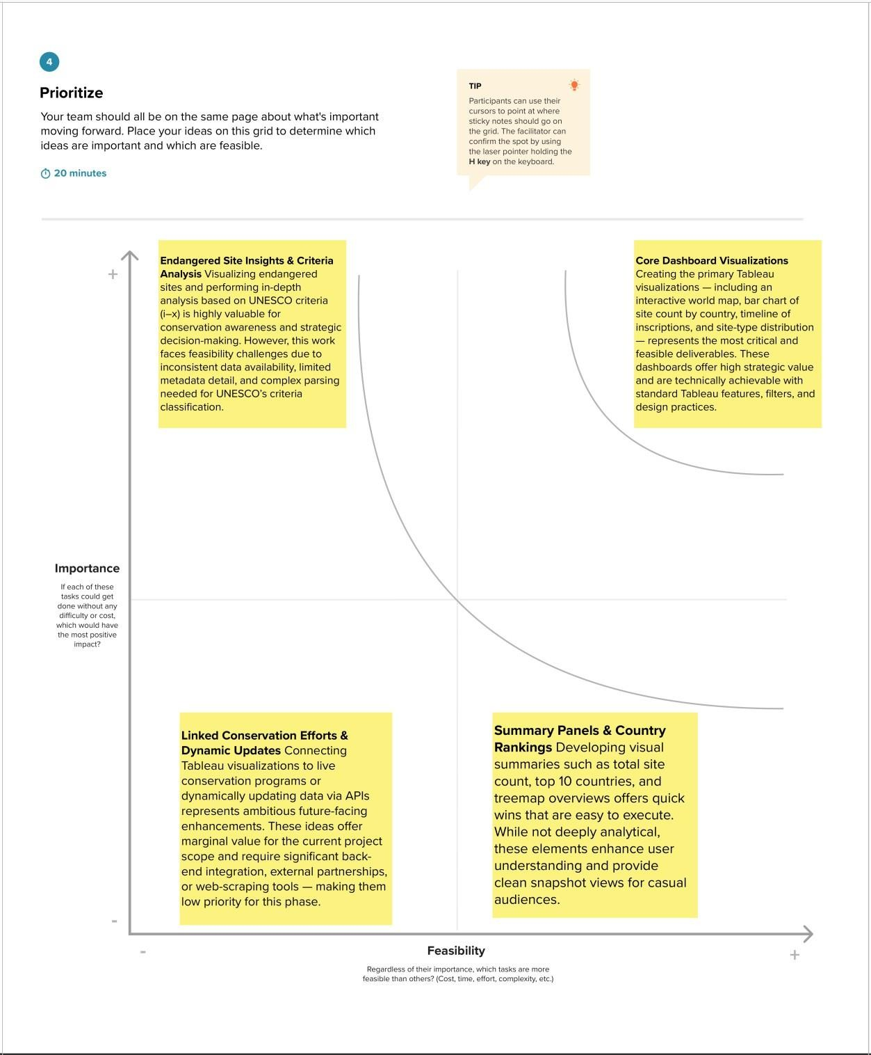

Ideation Phase Define the Problem Statements

Date | JULY 2026
Team ID
Project Name | Heritage Treasures: An In-Depth Analysis of UNESCO World Heritage Sites in Tableau
Maximum Marks | 2 Marks

Customer Problem Statement Template:
Create a problem statement to understand your customer's point of view. The Customer Problem Statement template helps you focus on what matters to create experiences people will love.
A well-articulated customer problem statement allows you and your team to find the ideal solution for the challenges your customers face. Throughout the process, you’ll also be able to empathize with your customers, which helps you better understand how they perceive your product or service.

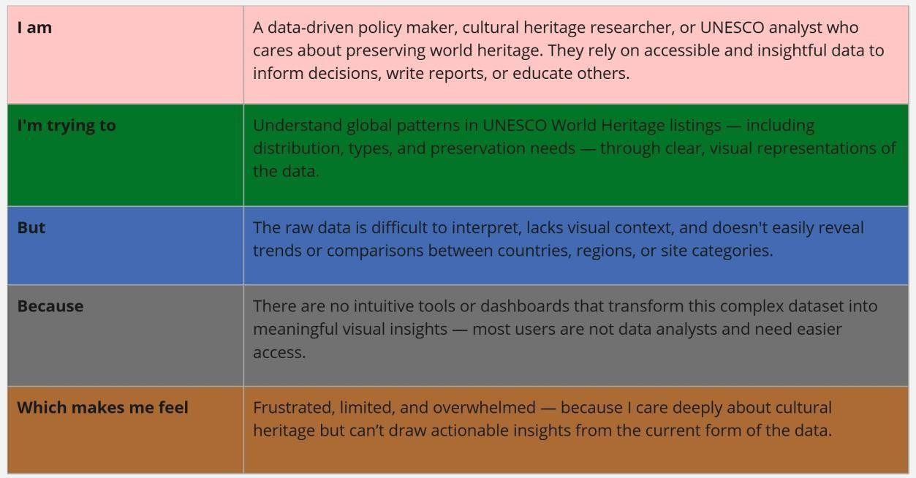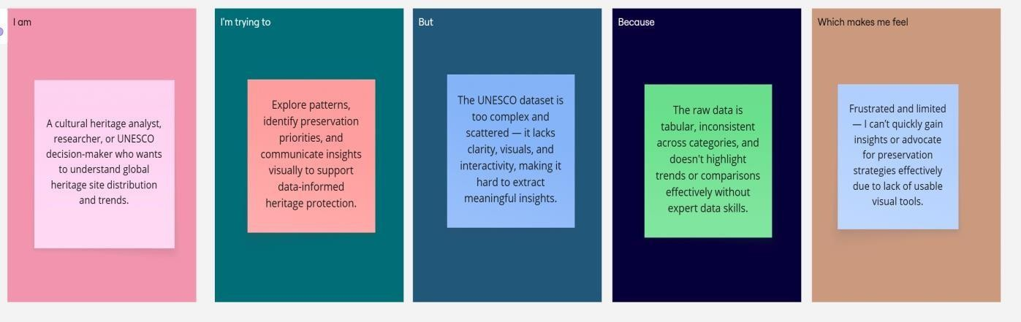
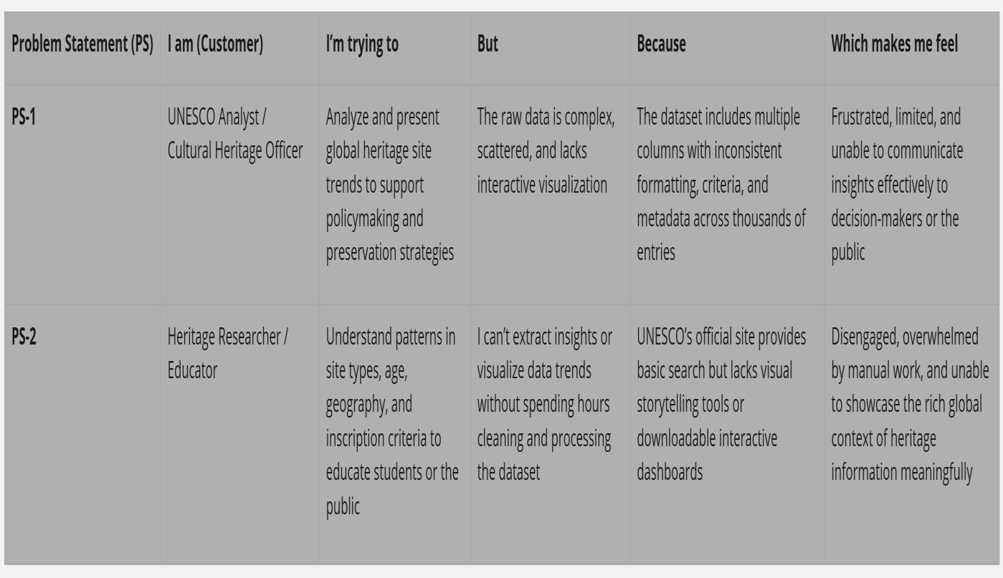

Ideation Phase Empathize & Discover

Date | JULY 2026
Team ID
Project Name | Heritage Treasures: An In-Depth Analysis of UNESCO World Heritage Sites in Tableau
Maximum Marks | 4 Marks

Empathy Map Canvas:
An empathy map is a simple, easy-to-digest visual that captures knowledge about a user’s behaviours and attitudes.

It is a useful tool to helps teams better understand their users.
Creating an effective solution requires understanding the true problem and the person who is experiencing it. The exercise of creating the map helps participants consider things from the user’s perspective along with his or her goals and challenges.

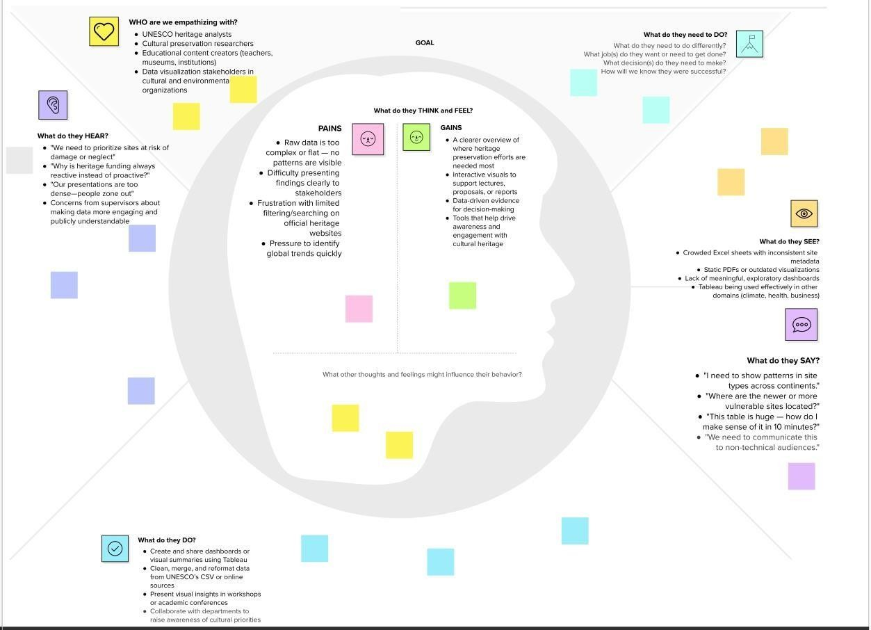

Project Design Phase-II
Data Flow Diagram & User Stories

Date | JULY 2026
Team ID
Project Name | Heritage Treasures: An In-Depth Analysis of UNESCO World Heritage Sites in Tableau
Maximum Marks | 4 Marks

Data Flow Diagrams:
A Data Flow Diagram (DFD) is a traditional visual representation of the information flows within a system. A neat and clear DFD can depict the right amount of the system requirement graphically. It shows how data enters and leaves the system, what changes the information, and where data is stored.
Flow Integration & Dependencies
Sequential Dependencies:
- Data Collection must be completed before Data Preparation
- Data Preparation enables effective Data Visualizations
- Visualizations form the foundation for Dashboard Creation
- Dashboards provide content for Story Development
- Performance Testing runs parallel to all development phases
- Web Integration requires completed dashboards and stories
- Documentation captures the entire development process

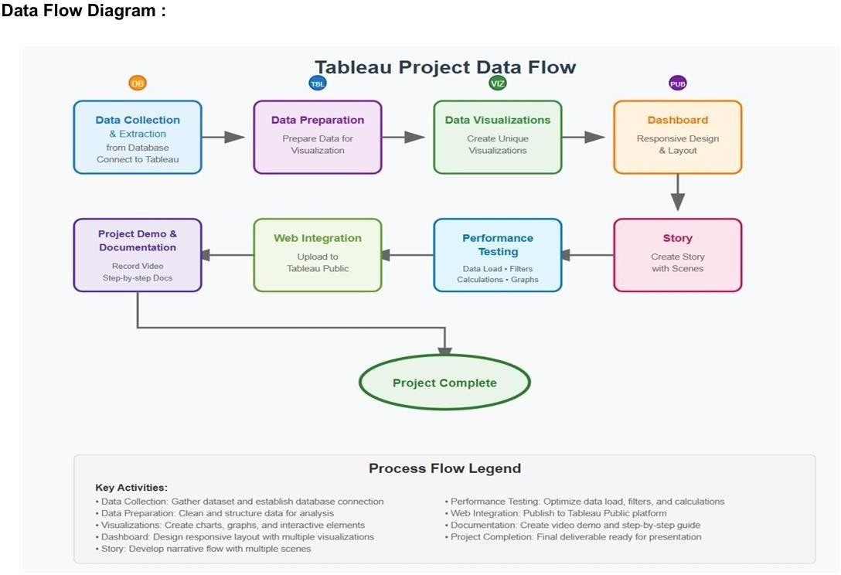

User Stories
Use the below template to list all the user stories for the product.

User Type | Functional  Requirement  (Epic) | User Story  Number | User Story / Task | Acceptance criteria | Priority | Release
Data Analyst | Dashboard  Performance  Optimization | USN-1 | As a Data Analyst, I want dashboards to load within 10 seconds even for global data, so users can explore without delay. | Dashboard loads under  10s; filters respond under 3s | High | Sprint-1
Project  Stakeholder | Data Overview  & Site Summary | USN-2 | As a stakeholder, I want to see total heritage site counts by region and category, so I can understand data coverage. | Display total site count, and percentage by category and region | High | Sprint-1
Cultural  Researcher | Heritage Sites  Risk Analysis | USN-3 | As a researcher, I want to view endangered sites and compare their areas and regions, so I can focus on high- risk zones. | Pie chart for Danger status, Top 10 danger sites by area | High | Sprint-1
UNESCO  Planner | Regional Trend  Insights | USN-4 | As a planner, I want to see how site inscriptions have changed over decades across regions, so I can assess growth trends. | Line chart with year- wise site count; region filter available | Medium | Sprint-1
Tourism Strategist | Category-wise Analysis | USN-5 | As a tourism strategist, I want to analyze which countries have more natural or cultural sites to plan destination marketing. | Bar chart by category, country filter enabled | Medium | Sprint-2
Policy Maker | Country/Region  Comparison | USN-6 | As a policymaker, I want to compare number of heritage sites per country within each region, to assess global representation. | Bubble chart by country within region; tooltip with site count | High | Sprint-2
Conservation  Team | Forecasting  Insights | USN-7 | As a conservation analyst, I want to forecast future site additions using historical data, to predict UNESCO activity. | Forecast chart using Date_inscribed, with estimate & actual series | High | Sprint-2

User Type | Functional  Requirement  (Epic) | User Story  Number | User Story / Task | Acceptance criteria | Priority | Release
Public User | Interactive  Dashboard  Access | USN-8 | As a public user, I want an integrated, interactive dashboard that is easy to navigate and informative. | Unified dashboard view with filters by region, year, danger | High | Sprint-3

Project Design Phase-II
Solution Requirements (Functional & Non-functional)

Date | JULY 2026
Team ID
Project Name | Heritage Treasures: An In-Depth Analysis of UNESCO World Heritage Sites in Tableau
Maximum Marks | 4 Marks

Functional Requirements:
Following are the functional requirements of the proposed solution.

FR No. | Functional Requirement (Epic) | Sub Requirement (Story / Sub-Task)
FR-1 | User Registration | Registration through Form Registration through Gmail
FR-2 | User Confirmation | Confirmation via Email Confirmation via OTP
FR-3 | Data Visualization | Filter by Region, Country, Year, Type Interactive  Dashboards (Maps, Bar Charts, Pie Charts)
FR-4 | Data Management | Upload UNESCO Dataset Clean/Transform data Export  Dashboard in PDF/Image
FR-5 | User Interaction | Hover-over Info Tooltips Search Feature Zoom on Map
FR-6 | Sharing & Access | Share Dashboard via Public Link Download Options for Reports

Non-functional Requirements:
Following are the non-functional requirements of the proposed solution.

FR No. | Non-Functional Requirement | Description
NFR-1 | Usability | Easy-to-navigate dashboards with intuitive filters and icons
NFR-2 | Security | Restricted access to edit data; secure sharing with view-only mode
NFR-3 | Reliability | Accurate data rendering without crashes or loading failures
NFR-4 | Performance | Dashboard loads within 3 seconds for standard datasets
NFR-5 | Availability | Dashboards accessible 24/7 through Tableau Public
NFR-6 | Scalability | Supports adding more countries/sites as data expands

Project Design Phase-II
Technology Stack (Architecture & Stack)

Date | JULY 2026
Team ID
Project Name | Heritage Treasures: An In-Depth Analysis of UNESCO World Heritage Sites in Tableau.
Maximum Marks | 4 Marks

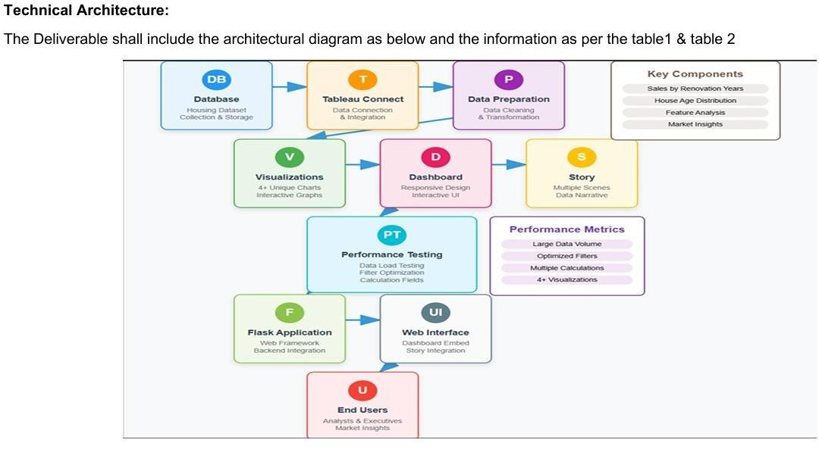
Table-1 : Components & Technologies:

S.No | Component | Description | Technology
1. | User Interface | Web-based dashboards for viewing and interaction | HTML, CSS, JavaScript / Tableau Public
2. | Application Logic-1 | Data preprocessing and transformation workflows | Tableau Prep Builder
3. | Application Logic-2 | Interactivity using filters, parameters, and actions | Tableau Filters, Parameters, Actions
4. | Dashboard/Story Logic | Logical flow of insights using story features | Tableau Story Feature
5. | Data Source | Flat files used as World Heritage datasets | CSV
6. | File Storage | Heritage datasets stored and accessed locally or from cloud storage | Local File System / Google Drive

Table-2: Application Characteristics:

S.No | Characteristics | Description | Technology
1. | Open-Source Frameworks | Uses open-source data (UNESCO dataset), hosted on Tableau Public | Dataset – UNESCO (CSV)
2. | Security Implementations | Basic security (view-only links, no edit access on public dashboard) | Tableau Public (limited)
3. | Scalable Architecture | Can scale by publishing to Tableau Cloud or embedding in websites | Tableau Cloud / Web Embed
4. | Availability | Dashboards accessible 24/7 via Tableau Public | Tableau Public
5. | Performance | Performs well with moderate data size; quick filter responsiveness | Tableau Public

References:
https://c4model.com/ https://developer.ibm.com/patterns/online-order-processing-system-during-pandemic/ https://www.ibm.com/cloud/architecture https://aws.amazon.com/architecture https://medium.com/the-internal-startup/how-to-draw-useful-technical-architecture-diagrams-2d20c9fda90d

Problem – Solution Fit Template
Date | JULY 2026
Team ID
Project Name | Heritage Treasures: An In-Depth Analysis of UNESCO World Heritage Sites in Tableau
Maximum Marks | 2 Marks

Problem – Solution Fit Template:
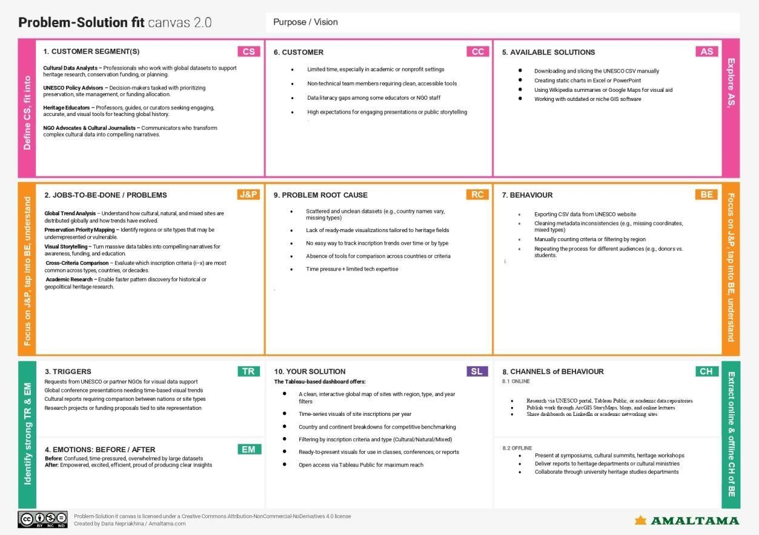
The Problem-Solution Fit simply means that you have found a problem with your customer and that the solution you have realized for it actually solves the customer’s problem. It helps entrepreneurs, marketers and corporate innovators identify behavioral patterns and recognize what would work and why
Purpose:
❑ Solve complex problems in a way that fits the state of your customers.
❑ Succeed faster and increase your solution adoption by tapping into existing mediums and channels of behavior.
❑ Sharpen your communication and marketing strategy with the right triggers and messaging.
❑ Increase touch-points with your company by finding the right problem-behavior fit and building trust by solving frequent annoyances, or urgent or costly problems.
❑ Understand the existing situation in order to improve it for your target group.

Template:

References:https://www.ideahackers.network/problem-solution-fit-canvas/

Proposed Solution Template
Date | JULY 2026
Team ID
Project Name | Heritage Treasures: An In-Depth Analysis of UNESCO World Heritage Sites in Tableau
Maximum Marks | 2 Marks

Proposed Solution Template:
Project team shall fill the following information in the proposed solution template.

S.No. | Parameter | Description
1. | Problem Statement (Problem to be solved) | UNESCO's World Heritage dataset is a globally important resource, yet it is presented in raw, tabular form that is difficult to interpret and explore visually. Researchers, policy makers, and educators often lack the tools to derive meaningful insights about the distribution, type, status, and trends of these heritage sites. This limit understanding and action for preservation, awareness, and advocacy.
2. | Idea / Solution description | We propose the development of a comprehensive, interactive Tableau dashboard that visualizes the UNESCO World Heritage Sites dataset from 2019. The dashboard will display site distribution by type (Cultural, Natural, Mixed), geographic region, year of inscription, and inscription criteria. It will include maps, bar charts, timelines, and filters to enable users to explore insights at global, national, or thematic levels. The solution will be hosted on Tableau Public for open access.
3. | Novelty / Uniqueness | Unlike existing static lists or basic maps, our solution provides live, filterable, and comparative visualizations that combine geospatial and temporal insights. The use of Tableau allows for real-time exploration without the need for coding, making the solution accessible to both technical and non- technical users in the heritage sector. No official interactive visualization tool of this depth exists for this dataset currently.
4. | Social Impact / Customer Satisfaction | This project enhances global heritage awareness and supports decision-making for cultural preservation. NGOs, heritage planners, educators, and students will benefit from easy access to visual insights. The platform enables deeper understanding of at-risk sites, regional inequalities, and long-term cultural patterns —

 |  | thereby supporting more equitable preservation efforts.
5. | Business Model (Revenue Model) | This is a non-commercial, open-access project primarily intended for social good and awareness. However, in the long term, this model could support:  - Partnerships with heritage NGOs or government bodies  - Workshops/training programs on  cultural data visualization  - Customized dashboards for country- specific or research-specific use cases on a paid or grant-supported basis
6. | Scalability of the Solution | The platform is highly scalable. It can:  - Be updated with newer UNESCO datasets annually  - Be expanded to include threatened site analysis, UNESCO funding records, or visitor statistics  - Be translated and localized for global use  - Integrate real-time APIs or mobile dashboards in the future

Solution Architecture
Date | JULY 2026
Team ID
Project Name | Heritage Treasures: An In-Depth Analysis of UNESCO World Heritage Sites in Tableau
Maximum Marks | 4 Marks

Solution Architecture:
Solution architecture is a complex process – with many sub-processes – that bridges the gap between business problems and technology solutions. Its goals are to:

- Find the best tech solution to solve existing business problems.
- Describe the structure, characteristics, behavior, and other aspects of the software to project stakeholders.
- Define features, development phases, and solution requirements.
- Provide specifications according to which the solution is defined, managed, and delivered.
Example - Solution Architecture Diagram:

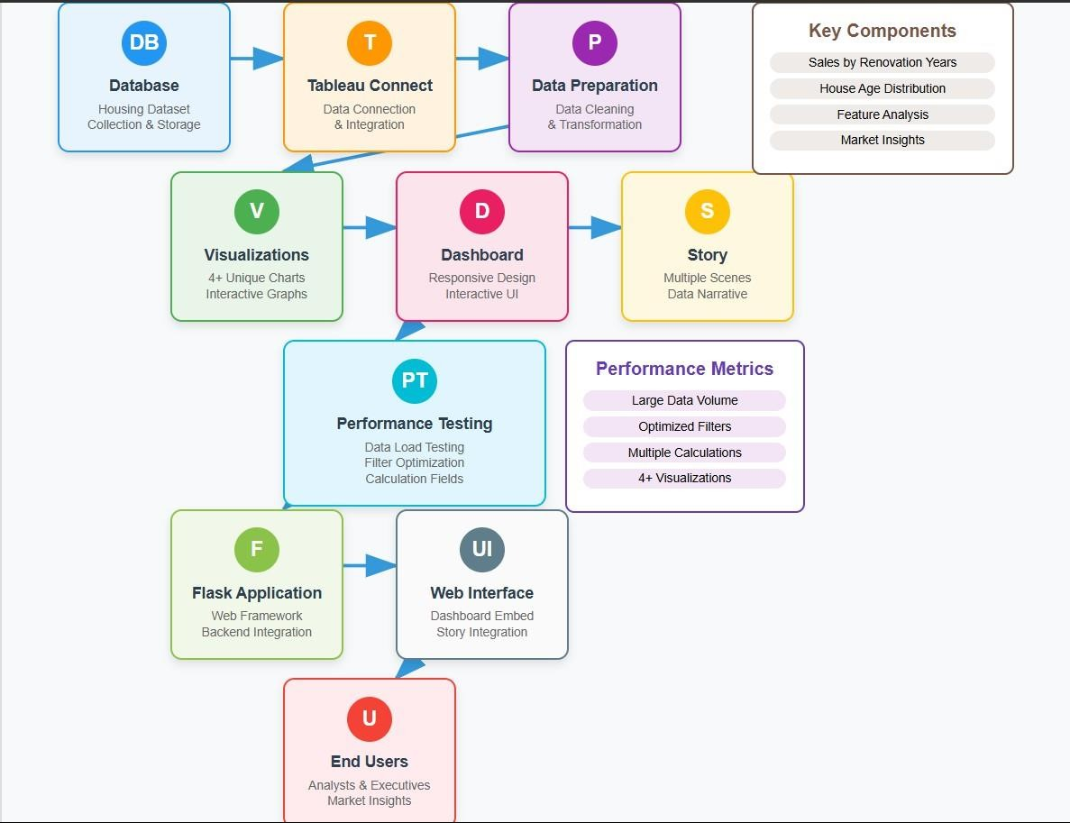
Figure 1: Architecture and data flow of the voice patient diary sample application
Reference: https://aws.amazon.com/blogs/industries/voice-applications-in-clinical-research- powered-by-ai-on-aws-part-1-architecture-and-design-considerations/

Planning Logic
A Sprint fixed period or duration in which a team works to complete a set of tasks
An Epic is a big task or project that is too large to complete in one sprint. It is broken down into smaller tasks (stories) that can be completed over multiple sprints.
A Story is a small task . It is part of an Epic.
A Story Point is a number that represents how much effort a story takes to complete.
(usually in form of Fibonacci series)
- Very Easy task
- Easy task
- Moderate task
5- Difficult task

Sprint 1: (5 Days)
Data Collection
Collection of Data 2
Loading Data 1
Data Preprocessing
Handling Missing Values 3
Handling Categorical values 2

Sprint 2 (5 Days)
Model Building
Model Building 5
Testing Model 3
Deployment
Working HTML Pages 3
Flask deployment 5

Total Story Points
Sprint 1 = 8
Sprint 2 = 16

Velocity= Total Story Points Completed/ Number of Sprints
Total story Points= 16+8 =24
No of Sprints= 2
Velocity = (16+8)/2= 24/2
12 (Story Points per Sprint)
Your team’s velocity is 12 Story Points per Sprint.

Project Planning Phase
Project Planning Template (Product Backlog, Sprint Planning, Stories, Story points)

Date | JULY 2026
Team ID
Project Name | Heritage Treasures: An In-Depth Analysis of UNESCO World Heritage Sites in Tableau
Maximum Marks | 5 Marks

Product Backlog, Sprint Schedule, and Estimation (4 Marks)
Use the below template to create product backlog and sprint schedule

Sprint | Functional  Requirement (Epic) | User Story  Number | User Story / Task | Story Points | Priority | Team  Members
Sprint-1 | Data  Understanding | USN-1 | As a data analyst, I want to collect the UNESCO Heritage Sites dataset. | 2 | High | JETTIGUNDLA GOVARDHAN REDDY
Sprint-1 | Data Preprocessing | USN-2 | As a data analyst, I want to clean and preprocess the dataset. | 3 | High | JETTIGUNDLA GOVARDHAN REDDY
Sprint-1 | Data Analysis | USN-3 | As a data analyst, I want to explore trends by region and site type. | 2 | Medium | B.AKSHAYA
Sprint-2 | Visualization | USN-4 | As a user, I want to visualize global site distribution on a map. | 3 | High | B.DILEEP KUMAR
Sprint-2 | Visualization | USN-5 | As a user, I want bar charts showing number of sites by country/year. | 3 | High | A.MANOJ KUMAR
Sprint-2 | Insights | USN-6 | As a user, I want to identify trends in inscription years and site types. | 3 | Medium | B.DILEEP KUMAR
Sprint-2 | Deployment | USN-7 | As a team, we want to publish and share the Tableau dashboard effectively. | 4 | High | B.AKSHAYA
Project Tracker, Velocity & Burndown Chart: (4 Marks)

Sprint | Total Story Points | Duration | Sprint Start Date | Sprint End Date (Planned) | Story Points  Completed (as on  Planned End Date) | Sprint Release Date (Actual)
Sprint-1 | 7 | 5 Days | 19 June 2026 | 24 June 2026 | 7 | 19 June 2026
Sprint-2 | 13 | 5 Days | 24 June 2026 | 29 June 2026 | 13 | 24 June 2026

Velocity:
Imagine we have a 10-day sprint duration, and the velocity of the team is 20 (points per sprint). Let’s calculate the team’s average velocity (AV) per iteration unit (story points per day)

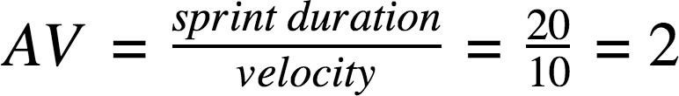

Burndown Chart:

A burn down chart is a graphical representation of work left to do versus time. It is often used in agile software development methodologies such as Scrum. However, burn down charts can be applied to any project containing measurable progress over time.

https://www.visual-paradigm.com/scrum/scrum-burndown-chart/

https://www.atlassian.com/agile/tutorials/burndown-charts

Reference: https://www.atlassian.com/agile/project-management https://www.atlassian.com/agile/tutorials/how-to-do-scrum-with-jira-software https://www.atlassian.com/agile/tutorials/epics https://www.atlassian.com/agile/tutorials/sprints https://www.atlassian.com/agile/project-management/estimation https://www.atlassian.com/agile/tutorials/burndown-charts

Project Development Phase Model Performance Test

Date | JULY 2026
Team ID
Project Name | Heritage Treasures: An In-Depth Analysis of UNESCO World Heritage Sites in Tableau
Maximum Marks

Model Performance Testing:
Project team shall fill the following information in model performance testing template.

S.No. | Parameter | Screenshot / Values
1. | Data Rendered | 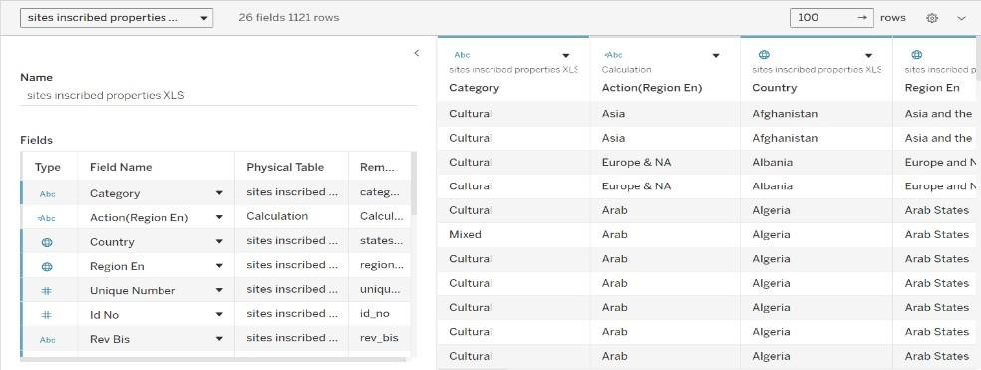  Successfully imported UNESCO dataset with fields including Name_en, Country, Region, Danger, Date_inscribed, and more. Data is correctly displayed in Tableau and linked to visualizations.
2. | Data Preprocessing | Removed missing/null values, ensured data types (dates, strings, boolean) were correctly set, and added calculated fields such as year extraction from Date_inscribed. Filtered out redundant columns. Number of rows after cleaning data:1121
3. | Utilization of Filters | Implemented filters on Country, Region, Danger Status, and Year. Filters are interactive and applied to all visualizations for dynamic exploration.

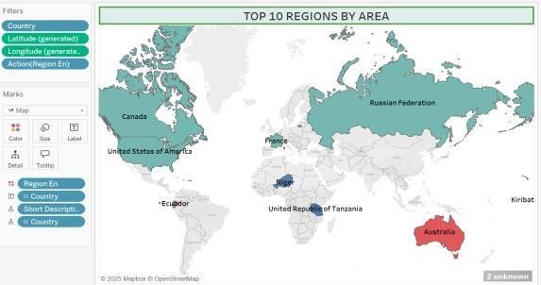
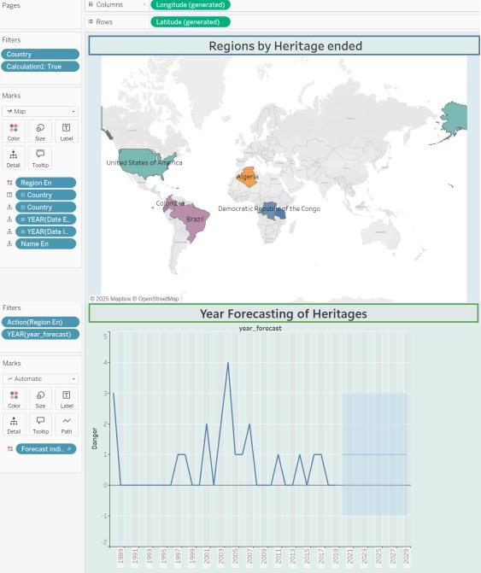
4. | Calculation fields Used | Year Extracted from Date_inscribed  - Count of Sites by Country  - Danger Flag Conversion for Pie Chart (IF [Danger] = 'Yes' THEN 'In Danger' ELSE 'Not in Danger')  - Region-wise Risk Rate: SUM(IF [Danger] = 'Yes' THEN 1 ELSE 0) / COUNT([Name_en])  - Decade of Inscription: INT(YEAR([Date_inscribed]) / 10) * 10  - Country-wise Site Percentage: (COUNTD([Name_en]) / TOTAL(COUNTD([Name_en]))) * 100
5. | Dashboard design | No of Visualizations / Graphs – 8 No of Dashboards designs- 2

 |  | 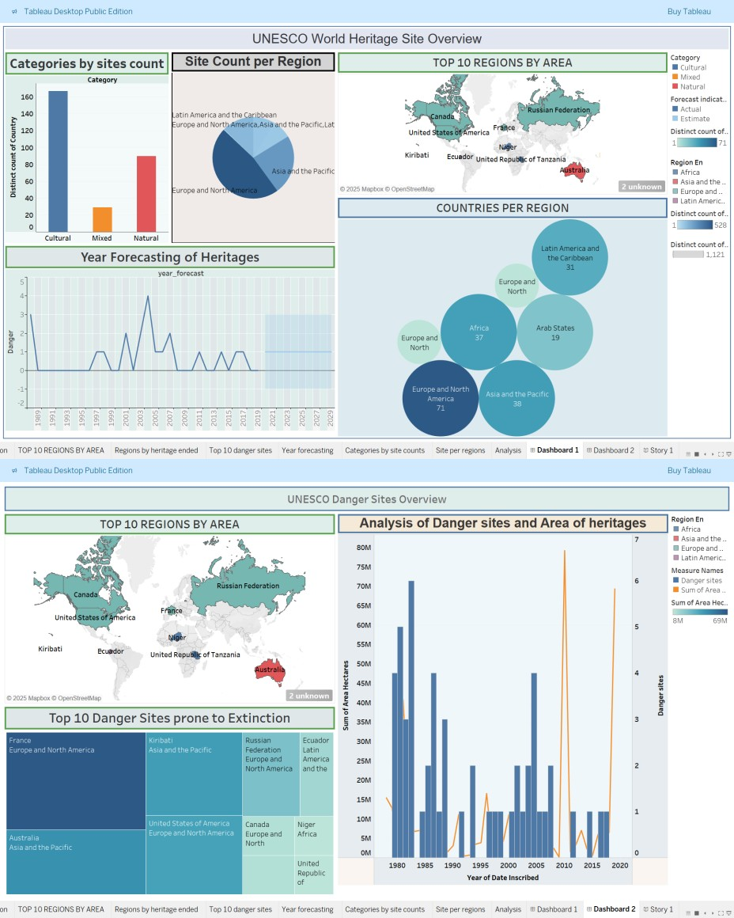
6 | Story Design | No of Visualizations / Graphs -8 No of Story Design- 1

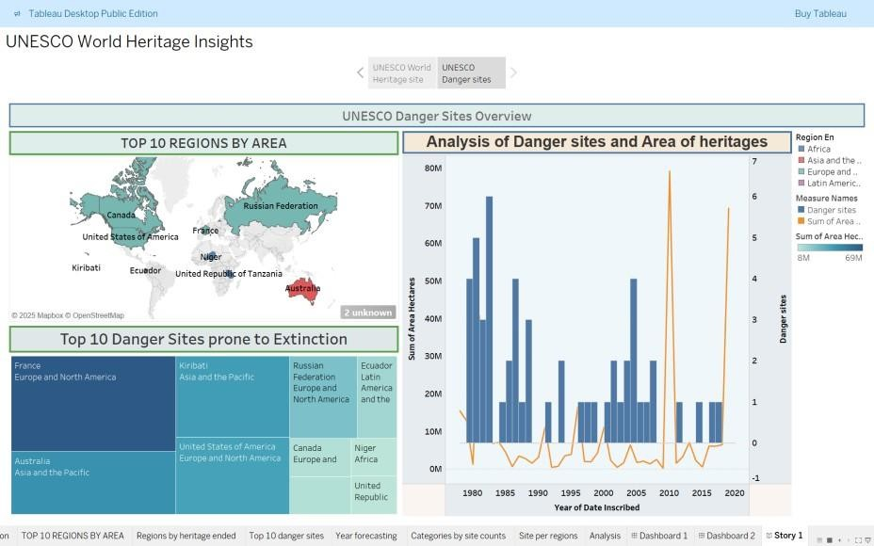

RESULTS
Date : 28 June 2025
Team ID: LTVIP2025TMID50324
Project Name: Heritage Treasures: An In-Depth Analysis of UNESCO World Heritage Sites in Tableau.

Dashboard – 1: UNESCO WORLD HERITAGE SITE OVERVIEW

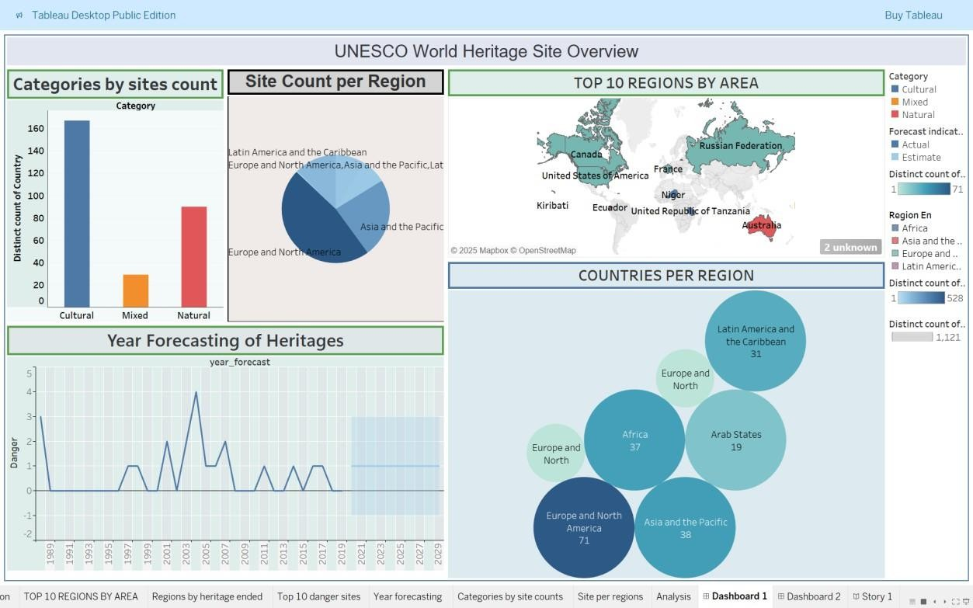

Dashboard – 2: UNESCO DANGER SITE OVERVIEW

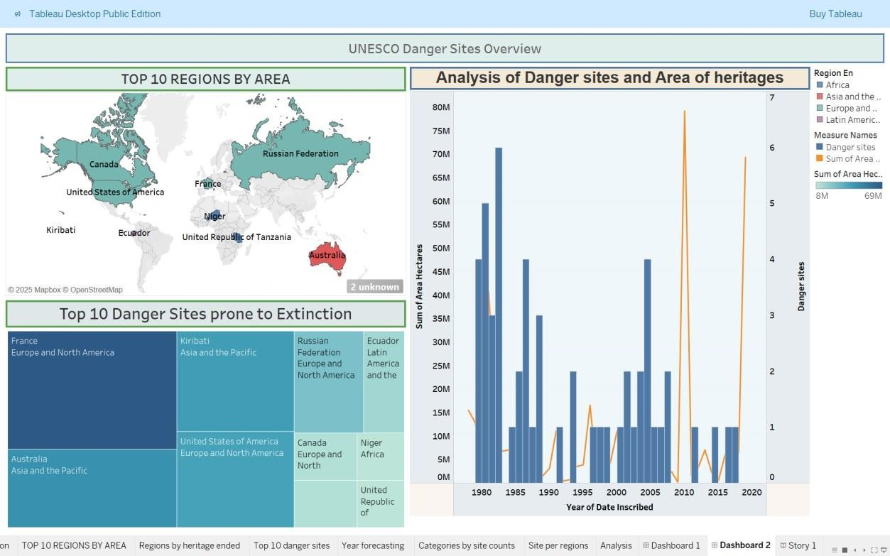

Story: UNESCO WORLD HERITAGE INSIGHTS

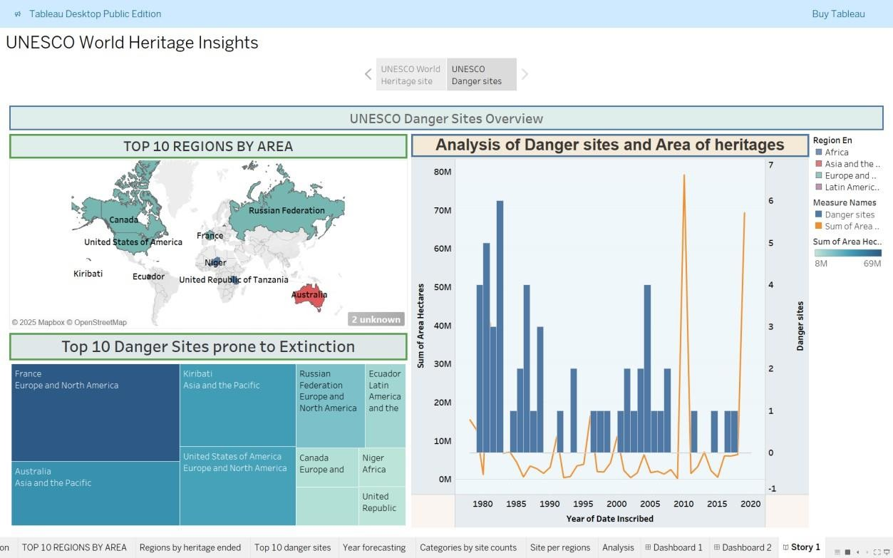

References
- UNESCO World Heritage Centre: https://whc.unesco.org/
- Tableau PuBLIC: https://public.tableau.com/app/profile/jettigundla.govardhan.reddy/viz/newunesco_17833612966560/Dashboard2?publish=yes
- Dataset Link: https://www.kaggle.com/datasets/ujwalkandi/unesco-world-heritagesites/data?select=whc-sites-2019.csv

